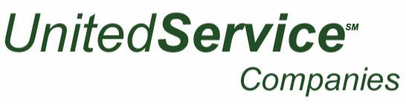

1550 S. Indiana Avenue - Chicago, IL 60605 – 312/922-8558 – F 312/922-2477

Job Description: Lobby Attendant
Company: United Maintenance
Reports to: Supervisor
Category: Full-time
Status: Non-exempt/Hourly
Maintain cleanliness of all public areas and health club (if applicable) at all times, ensuring all guest needs are met.
Specific Responsibilities:
- Ensure the utmost in customer service delivery
- Complete tasks as assigned via the daily checklist
- Inspect health club, public areas ensuring cleanliness rises to level expected by hotel client
- Wash/dry/fold towels for health club area
- Check lobby area for debris, refuse
- Monitor front drive area for cleanliness
- Clean/maintain lobby bathrooms & elevators
- Respond to guest requests within fifteen (15) minutes
- Maintain satisfactory guest survey scores
- Maintain professional appearance expectations
- Other duties as may be assigned
Qualifications:
- Must have ability to prioritize and organize work
- Must be able to multitask
- Attention to detail is a must
- Ability to work well with others
- Basic skill to comprehend English
- Capable of lifting, bending, stooping, pushing & pulling heavy loads
- Flexible schedule required, including a willingness to work AM/PM shifts, weekends and holidays

