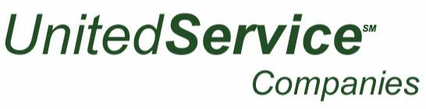

1550 S. Indiana Avenue - Chicago, IL 60605 – 312-922-8558 – F 312-922-2477

Job Description: Line Cook
Company: United Maintenance
Reports to: Area Manager
Category: Full-time

We are on the hunt for an experienced Line Cook to join our talented team and help prepare meals according to our standard recipes. In this position, your principal goal will be to prepare high-quality meals that meet the chef’s exact specifications. You will be responsible for setting up the prep station, stocking inventory, and maintaining sanitation standards. To be successful in this role, the ideal candidate will possess excellent communication and multi-tasking skills. Ultimately, you will play an essential role in contributing to our customer satisfaction.
Responsibilities for Line Cook
- Prepare ingredients then cook and assemble dishes as indicated by recipes
- Perform portion control and minimize waste to keep cost within forecasted range
- Ensure that all dishes are prepared in a timely manner by restocking ingredients at work station and meeting prep times to ensure smooth delivery
- Set up and clean station according to restaurant protocol
- Maintain a clean work station area, including kitchen equipment, tables, and shelves
- Comply with applicable sanitary, health, and personal hygiene standards
- Ensure quality and freshness of ingredients and products
- Perform additional tasks as assigned by the line supervisor, sous-chef, or executive chef
Qualifications
- High School Diploma or equivalent required; culinary degree preferred
- 1 years of experience cooking in a restaurant, hotel, or resort
- Understanding of cooking methods and procedures, and knife handling skills
- Ability to perform tasks with accuracy, speed, and attention to detail
- Ability to read and follow cooking directions
- Ability to remain calm in a fast-paced environment
- Must be organized and self-motivated
- Must be able to stand, bend, stretch, and lift, and carry heavy materials

